Software Requirements Specification

PRJ566 – Winter 2025

PRJ566 – Team No: 1

Name of Project: Socs (Socials Opportunities Careers)

Project Leader: Pak Oxana

Last updated: 22.01.2025

Team Members:

1. Connor McDonald
2. Supachai Ruknuy
3. Shayan Shimura
4. Pak Oxana

TABLE OF CONTENTS

- Introduction/Overview - Document Information
  - Document Authors
  - Revision History
  - Document Conventions
  - Document Purpose
  - Intended Audience
  - Group Agreement

- Project Overview
  - Project Proposal
  - Stakeholders and Users
  - Project Scope
  - Functional Requirements
  - Nonfunctional Requirements
  - System risks
  - Operating Environment
  - UI/UXD Interface Mockups

- Process & Data Modeling
  - UML Modeling: DFDs & Activity Diagrams
  - Use Case Specification
    - Business Rules
    - System Use Case Diagrams
    - Use Case Description Tables

- Domain Class Diagram
- Database (Select either 5.1 or 5.2)
  - RDBMS Artifacts
    - Scripts to create, populate, delete tables
    - Data Dictionary
  - NoSQL Artifacts

- Work breakdown Structure (WBS)
- Milestones & Acceptance Criteria
- Implementation Schedule (Agile/Waterfall)
- Client / Faculty Sign-off

1 - Introduction/Overview - Document Information

1.1 Document Authors
- Connor McDonald
- Supachai Ruknuy
- Shayan Shimura
- Oxana Pak

1.2 Revision History
Week 03 | Completed and update section 1.1 - 2.1,  1.1 Document Authors [COMPLETED]  1.2 Revision History [COMPLETED]  1.3 Document Conventions [COMPLETED]  1.4 Document Purpose [COMPLETED]  1.5 Intended Audience [COMPLETED]  1.6 Group Agreement [COMPLETED]  2.1 Project Proposal [COMPLETED]
Week 04 | Added and completed sections 2.2, 2.3, 2.6, 2.7  2.2 Stakeholders and Users [COMPLETED]  2.3 Project Scope [COMPLETED]  2.6 System Risks [COMPLETED]  2.7 Operating Environment [COMPLETED]
Week 05 | Added and completed sections 2.4, 2.5  2.4 Functional Requirements [COMPLETED]  2.5 Non-Functional Requirements [COMPLETED]
Week 06
Week 07
Week 08
Week 09
Week 10
Week 11
Final

1.3 Document Conventions
Convention | Definition
Red text | Indicates errors, exceptions, or critical warnings.
Blue Text | Indicates tasks or sections that are currently in progress or pending review.
Yellow Highlight | Marks important points or key takeaways that require special attention.
Green Text | Represents recently added content or updates.
Strike-through Text | Indicates deleted or obsolete content that is no longer relevant.
Bold text | Emphasizes crucial information or headers.
Underlined text | Hyperlinks or navigation links
Aptos Mono Font | Used for code snippets, commands, or technical instructions.
- Bulleted Lists | Present unordered lists or key points for easy readability.
- Numbered Lists | Used for steps in a process or ordered sequences.

1.4 Document Purpose

This document was created to describe the software requirements for the Socs project. Its purpose is to ensure that project team members and stakeholders understand the technical requirements and align their contributions to meet the project’s goals. The document provides a complete guide to the development of a unique social media application that promotes professional connections and collaboration across organizations and individuals.

1.5 Intended Audience

The intended audience for this software requirements specification is the following groups:
- Project Stakeholders - Individuals with an interest in the project's success who need to understand the requirements to ensure alignment with business goals
- Development Team - Engineers and developers who will use the SRS to guide the technical implementation of the software.
- Project Manager - Leader responsible for planning, executing, and monitoring the project
- Visual Designers - Design professionals who need the SRS to create user interfaces and experiences.
- Vendors and Suppliers - External parties providing components or services, who require the SRS to ensure their offerings align with the project's needs.

1.6 Group Agreement
TEAM AGREEMENT
Team #: 1
Project Title: Socs (Socials Opportunities Careers)
Project Time Frame:
Team Members:
- Connor McDonald – Backend Programmer/Designer
- Oxana Pak – Project Manager/Backend Programmer
- Supachai Ruknuy – Frontend Programmer/Designer
- Shayan Shimura – Frontend Programmer/Backend Programmer
Team Leadership: Pak Oxana
Team Functions:
- We will share information through MS Teams
- We will communicate using MS Teams group messages and team calls
Team Meetings:
Tuesday: 3:00 – 3:30 (PM)
Wednesday: After the class for 30 minutes
Team Problems:
Team members are not finishing their tasks on time and not responding to messages.
Team Commitment
The undersigned members agree to work together on the project until the end of the PRJ666 next Semester. They recognize that as a team and individually they are responsible for the quality of all deliverables.
Name Date
Connor McDonald | Jan 22, 2025
Shayan Shimura | Jan 22, 2025
Pak Oxana | Jan 22, 2025
Supachai Ruknuy | Jan 22, 2025

2 - Project Overview

2.1 Project Proposal
Socs is an app designed to streamline the process of interacting with other working professionals, combining a social media platform with a document editing collaboration tool. Our goal is for this app to be a single stop where users can stay connected and work with each other, without the need to switch applications or go elsewhere.

Currently there is no platform that unifies collaboration and networking. The current offerings are hyper focused, either being social media platforms that let you post and react, or collaboration tools that let you work simultaneously with others but with no way to communicate. Our idea is to fill this gap with a service that offers the social media aspect, but with a way to evolve those connections into true collaborations with audio and voice calls, and multi-user document collaboration.

Problem Statement
The Problem of: | Lack of a platform that unifies communication, networking, and collaboration
Affects: | Working professionals in any field
The impact of which is: | Users must jump from platform to platform, which is both incredibly inconvenient and a point of disconnect where users may choose to stop.
A successful solution would: | Provide the networking/social media opportunities offered by platforms like LinkedIn but with fleshed out collaboration and AV communication tools seamlessly built in.
Product Vision
For | Working professionals in any field
Who | Are looking to collaborate with other professionals external to their own company/environment
The Product Name | Is a social media and collaboration platform named Socs
That | Combines the tools needed to work collaboratively and simultaneously with the features of a social media and networking platform.
Unlike | LinkedIn which focuses solely on the social media aspects, and Microsoft Teams which has a limited suite of collaboration tools and none of the externality, or Google Cloud that has the externality but none of the communication.
Our product | Allows users to have the experience of networking outside of your team and company, with the tools to collaborate and communicate with those new and existing members of your network.

2.2 Stakeholders and Users

Stakeholders
- Investor: Angel Investors
- Project Manager
- Development team
- Designers
- Marketing team
- Customer support team

Users
- Job/Project Seekers
- Working Professionals
- Recruiter
- Companies
- Advertisers
- Students

2.3 Project Scope

2.3.1 Objectives
- Develop a web-only application that combines professional networking with real-time collaboration tools.
- Provide a single platform where users can connect, post, comment, direct message, voice/video call, and collaborate on documents in real time.
- Ensure seamless communication and collaboration without needing external tools.
- Maintain high security, scalability, and performance to support professional interactions.

2.3.2 Key Deliverables

Frontend
- User Profiles & Connections:
  - Account creation with professional details.
  - Ability to add and follow connections.
- Social Feed & Engagement:
  - Users can create posts, comment, and react.
  - Hashtags and content categorization.
- Direct & Group Messaging:
  - Real-time messaging with file sharing.
  - Read receipts and typing indicators.
- Voice & Video Calls:
  - One-on-one and group calls.
  - Screen sharing and call recording options.
- Real-Time Document Collaboration:
  - Multi-user document editing with version control.
  - Commenting and inline discussions.
  - Access control for document permissions.
- Notifications & Alerts:
  - System notifications for messages, comments, and collaboration invites.

Backend Services
- API Services:
  - User authentication and profile management.
  - Social feed interactions (posting, commenting, reacting).
  - Messaging, voice, and video call handling.
  - Document storage and version control.
- Database Management:
  - Storing user profiles, posts, and connections.
  - Document collaboration history.
  - Chat logs and call records.

Admin Panel (Web-Based Interface)
- User Management: Account creation, approval, and moderation.
- Content Oversight: Monitor flagged posts and reported users.
- System Performance: Track API usage, errors, and analytics.

Other Deliverables
- Testing Artifacts:
  - Functional, UI/UX, and performance testing reports.
  - Security assessments for messaging and document sharing.
- Documentation:
  - API and backend service documentation.
  - User guides for onboarding and feature usage.

2.3.3 Core Features

For Users
- Build professional connections and engage in discussions.
- Create and edit shared documents with version tracking.
- Direct message and start voice/video calls with individuals or groups.
- Post updates, comment on posts, and react to content.

For Administrators
- Manage user accounts and permissions.
- Monitor platform activity and enforce community guidelines.
- Oversee collaboration metrics and engagement trends.

2.3.4 Out of Scope
- No mobile or desktop applications.
- No AI-powered content moderation at launch.
- No third-party integrations for document collaboration in the initial phase.

2.3.5 Technical Requirements
- Scalability: Must support multiple users editing a document in real-time.
- Performance: Low-latency messaging and video calling.
- Security: End-to-end encryption for chat and document storage.
- Availability: Uptime of 99.9% for continuous collaboration.

2.3.6 Assumptions
- Users will access the platform via modern web browsers.
- Internet access is required for all functionalities.
- Video calls and document editing will be browser-based (no external apps needed).

2.3.7 Constraints
- Development timeline of 4 months with a team of 6.
- Budget limitations for initial infrastructure.
- Compliance with global data protection laws.

2.3.8 Timeline

Phase 1: Planning & Research (3 weeks)
- Gather user requirements and competitor analysis.
- Define core features and system architecture.

Phase 2: Design (4 weeks)
- UI/UX wireframing and prototyping.
- Define workflows for messaging, document collaboration, and calling.

Phase 3: Development (8 weeks)
- Backend API and database implementation.
- Frontend development for social feed, messaging, and collaboration tools.
- Integration of voice/video calling and document editing.

Phase 4: Testing & QA (3 weeks)
- Functional, performance, and security testing.
- Iterative refinements based on feedback.

Phase 5: Deployment & Launch (2 weeks)
- Final bug fixes and optimizations.
- Deployment and onboarding of initial users.

2.3.9 Success Criteria
- Active engagement in social networking and document collaboration.
- Reliable, low-latency messaging and calling.
- Secure platform with minimal downtime.
- At least 1000+ active users within the first 3 months.

2.4 Functional Requirement

2.4.1. Integrated Social Networking & Collaboration Workspace
Social Feed with Collaboration Tools
- Social Feed: Users can post updates, share articles, and engage with content (likes, comments, shares).
- Embedded Collaboration Tools: Allow users to create and share collaborative documents, spreadsheets, or presentations directly within the social feed.
- Real-Time Collaboration: Enable multiple users to edit documents simultaneously with live updates and version control.

Project-Based Networking
- Project Creation: Users can create public or private projects, invite collaborators, and share progress updates.

2.4.2 Audio/Video Communication & Collaboration
Seamless AV Integration
- In-App Audio/Video Calls: Users can initiate voice or video calls directly from the platform without switching apps.
- Screen Sharing & Whiteboard: Enable screen sharing and a virtual whiteboard for brainstorming sessions during calls.
Group Collaboration
- Groups: Create dedicated groups for teams or projects where users can drop in for discussions, share files, and collaborate in real-time.
- Recording & Transcription: Record meetings when necessary and provide transcripts for future reference.

2.4.3 Networking & Collaboration Recommendations
Smart Networking Suggestions
- Connections: Suggest potential collaborators or professionals based on shared interests, skills, or project history.
- Event Recommendations: Recommend networking events, webinars, or workshops based on user interests and professional goals.
Collaboration Insights
- Project Recommendations: Suggest relevant projects or tasks based on user skills, availability, and past collaborations.

2.4.4 Cross-Platform Synchronization & Offline Access
Multi-Device Sync
- Seamless Sync: Ensure all documents, messages, and project updates are synchronized across devices (web, mobile, desktop).
- Offline Access: Allow users to access and edit documents offline, with changes syncing automatically once reconnected.
Third-Party Integrations
- Tool Integrations: Integrate with popular tools like Google Drive for seamless workflow management.
- API for Developers: Provide an open API for businesses to integrate Socs with their existing systems.

2.4.5 Advanced Search and Discovery
Universal Search
- A global search bar that allows users to quickly find people, projects, documents, or messages.
- Supports filters (e.g., by date, relevance, tags, or user).
Contextual Search
- Search within specific sections like projects, messages, or groups.
Job Posting Search & Alerts
- Users can search for job postings by role, company, or location.
- Option to set up job alerts for new relevant postings.

2.4.6 User Engagement & Personalization
Customizable User Profiles
- Users can showcase their skills, experience, and portfolio.
- Option to highlight preferred collaboration types (e.g., freelance, startup projects, corporate teams).

Personalized Dashboard
- Users can view a tailored feed of job postings, projects, and collaboration requests.
- Quick access to active discussions, saved job postings, and scheduled meetings.
Smart Connection Suggestions
- Project & Job-Based Suggestions: Suggest professionals who have worked on similar projects or applied for similar job postings.
- 2nd-Degree Connection Suggestions: Recommend people your connections are connected to (friends of friends).
- Industry-Based Matching: Recommend users in the same industry or career path to foster relevant networking.

2.4.7 Smart Notification
Real-Time Notifications
- Instant alerts for new messages, collaboration requests, and project updates.
- Customizable notification settings (email, push, in-app).
Job & Project Activity Tracking
- Alerts for new job and project postings matching user preferences.
- Updates on applications, interviews, or project invites.

2.4.8 Security & Privacy
Authentication & Account Protection
- Does not allow any unauthorized account to access users' private information. If unauthorized accounts tried to access, it requires them to login.
- Multi-factor authentication (MFA) for added security.
Data Privacy & Control
- Users can control profile visibility (public, private, or connections-only).
- Granular settings for who can view posts, projects, and job applications.

2.5 Nonfunctional Requirements

2.5.1 Performance & Scalability
System Scalability
- Must support at least 50,000 concurrent users at launch, with the ability to scale to 500,000+ users as adoption grows.
- Horizontal scaling through containerized microservices (Docker, Kubernetes) for peak load handling.
- Designed for multi-organization usage, allowing different teams and companies to collaborate independently.

Response Time & Latency
- Feed and dashboard load time must be ≤1 second under normal conditions.
- Direct messages and comments must be delivered within 200ms to ensure real-time interaction.
- Voice and video calls should have ≤150ms latency for a smooth experience.
- Document collaboration updates must propagate to all users within 300ms.

Load Balancing & High Traffic Handling
- Load balancers will distribute traffic evenly across servers.
- CDN (Content Delivery Network) integration for faster content access across regions.
- Optimized WebRTC streaming for low-latency video calls and screen sharing.

2.5.2 Security & Data Privacy
User Authentication & Access Control
- Multi-factor authentication (MFA) for all users.
- Role-based access control (RBAC) for managing user permissions.
- OAuth 2.0 & SSO (Single Sign-On) integration for enterprise users.

Data Encryption & Protection
- AES-256 encryption for sensitive user data.
- End-to-End Encryption (E2EE) for direct messaging and voice/video calls.
- Tokenized API access to prevent unauthorized interactions.
Compliance & Regulatory Standards
- GDPR compliance for user data protection.
- WCAG 2.1 accessibility compliance for usability across different abilities.
- SOC 2 compliance for secure cloud infrastructure.

2.5.3 Availability & Reliability
Uptime & Failover Mechanisms
- 99.9% uptime target with failover mechanisms in place.
- Geo-redundant servers to maintain service during regional outages.
- Daily automated backups for document and message history recovery.

Disaster Recovery
- Multi-region data replication for real-time failover.
- Recovery Time Objective (RTO) ≤ 10 minutes to restore services after failures.
- Recovery Point Objective (RPO) ≤ 5 minutes to minimize data loss.

2.5.4 Usability & Accessibility
User Experience (UX) Standards
- Minimal learning curve with an intuitive UI.
- Customizable UI preferences, including light/dark mode.
- Seamless transitions between social features and document collaboration.

Multi-Device & Multi-Browser Support
- Full support for Chrome, Firefox, Safari, and Edge.
- Responsive design to work across desktop, tablet, and mobile browsers.

Accessibility Compliance
- Screen reader compatibility for visually impaired users.

2.5.5 Maintainability & Extensibility
Modular Microservices Architecture
- Independent microservices for authentication, messaging, collaboration, and video calls.
- API-first approach to allow third-party integrations (e.g., Google Drive, Notion).

Continuous Integration & Deployment (CI/CD)
- Automated testing and deployment pipelines using GitHub Actions.
- Feature flagging to enable or disable new features dynamically.
- Versioned APIs to maintain backward compatibility.

Logging & Monitoring
- Centralized logging (ELK Stack, Datadog) for tracking system errors.
- AI-driven anomaly detection to identify unusual activity.
- Automated alerts for performance degradation.

2.5.6 Collaboration & Communication
Real-Time Document Collaboration
- Multi-user editing with live updates and version tracking.
- Role-based permissions for viewing and editing documents.

Video & Voice Calls
- End-to-end encrypted WebRTC calls for secure communication.
- Noise suppression to improve call quality.

2.5.7 AI & Predictive Analytics
User Engagement Analytics
- Activity tracking to measure engagement across posts, messages, and collaboration tools.
- Usage heatmaps to identify feature adoption and optimize UI/UX.

Admin Dashboards
- Real-time monitoring of platform activity (e.g., active users, document edits).
- Automated moderation alerts for flagged content.
- Performance analytics for messaging, calling, and document collaboration.

2.5.8 Multi-Language & Localization
- Multilingual UI support (starting with English, French, Spanish).
- Right-to-left (RTL) text support for Arabic and Hebrew.

2.6 System Risks
Risk | Response
The use of voice and video communication adds complexity, increasing potential security vulnerabilities. | Implement end-to-end encryption for all communication features. Regularly conduct security audits and ensure modular code to make updates and vulnerability fixes efficient.
The integration of multiple features ( communication, collaboration) increases system complexity and testing challenges. | Use agile methodologies to implement features incrementally and test each component thoroughly before integration. Allocate extra resources for system testing and debugging.
High server load due to real-time collaboration and large-scale communication features, leading to potential downtime. | Implement scalable cloud infrastructure to handle fluctuating workloads. Use load-balancing techniques and conduct stress tests to identify and address performance bottlenecks.
Challenges in user adoption due to competition from established platforms like LinkedIn and Microsoft Teams. | Develop a strong marketing strategy highlighting unique features of Socs, such as the seamless integration of networking and collaboration tools. Offer free trials or discounted rates to attract initial users and gather feedback for improvements.

2.7 Operating Environment

The SOCS web application is built using a modern tech stack that leverages both frontend and backend technologies to provide a seamless user experience across browsers such as Google chrome, Firefox, and Microsoft Edge.

The SOCS application is designed to run on the following platforms:
- Web Browsers: Compatible with modern web browsers like Google Chrome, Firefox, and Microsoft Edge.
- Operating Systems: Can be accessed on any operating system (Windows and macOS) that supports the above browsers.
- Devices: Responsive design ensures compatibility with desktops, laptops, tablets, and mobile devices.

Here's a breakdown of the technologies and their roles:

Frontend (User interface)
- Next.js Framework: A React-based framework that provides reusable components to develop user interfaces with optimized performance out of the box.
- Tailwind CSS: A utility-first CSS framework that allows for rapid UI development.
- Shadcn/ui: A collection of customizable UI components built on top of Tailwind CSS.
- TypeScript: Provides type check, error detection and maintainability.

Backend (Server)
- Node.js: A JavaScript runtime that allows for building scalable and high-performance server-side applications.
- Express.js: Provides routing, middleware support, and easy integration with databases and APIs.
- MongoDB: A NoSQL database that stores data in a flexible format.

Third Party
- NextAuth.js: A complete authentication library for Next.js applications, support
- Twilio: A cloud communications platform used for sending SMS messages and receiving phone calls.
- Google doc: Enhances functionality with authentication (NextAuth.js), communication (Twilio), and document management (Google Docs API).

2.8 UI/UXD Interface Mock-ups

UI/UXD Interface URL: https://www.figma.com/design/qTdXt4YU0OjDOPysWMtIye/Socs-App?node-id=0-1&p=f&t=G7Pj3a0kYR9U7boP-0

3 - Process and Data Modeling

3.1 UML/DFD Modeling and Data Modeling

Data Flow Diagrams

User Authentication
System
User
Login/Create Account/Manage Profile

Store/Retrieve User Data

Post Management
Create/Edit/Delete/Favorite Posts
System
User

Store/Retrieve Post Data

Messaging
Send/Receive Messages
User
System

Store/Retrieve Messages

Call and video
System
Initiate/Receive Calls
User

Stream Call/Video Data

Document Collaboration
Upload/Share/Edit Documents
System
User

Store/Retrieve Documents

Activity Diagrams

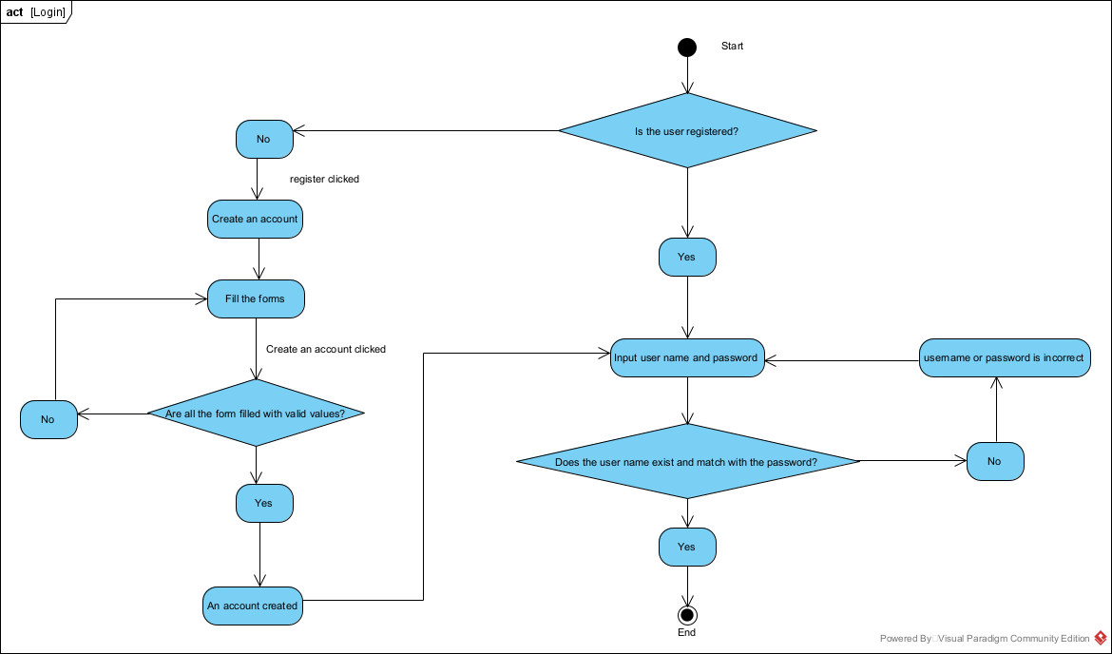
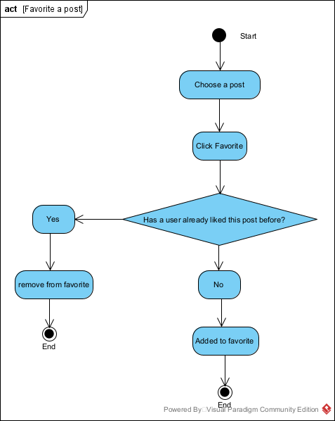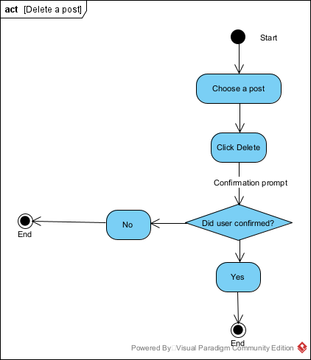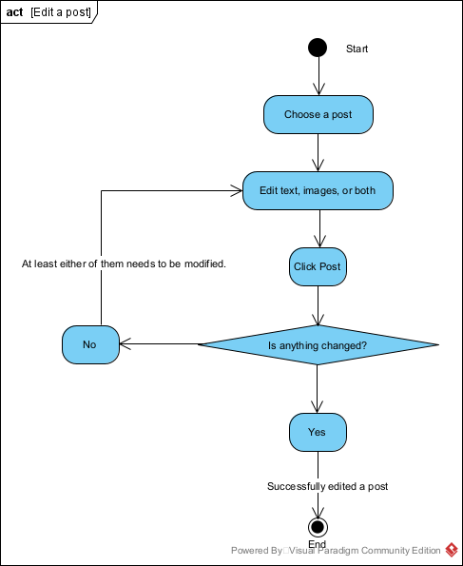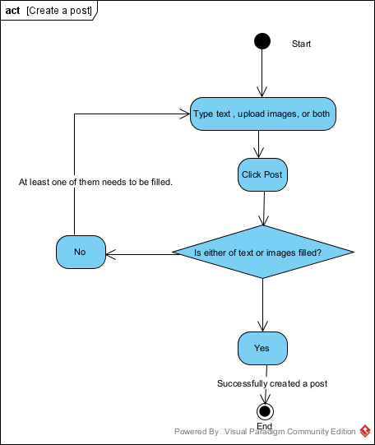

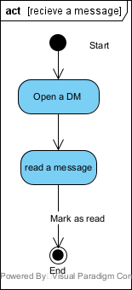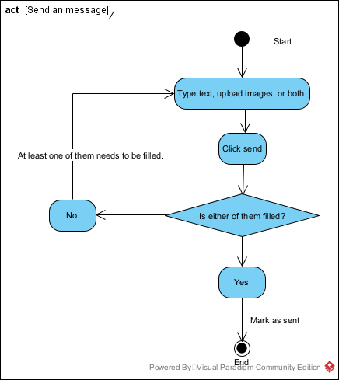

3.2. Use Case Specification

3.2.1. Business Rules

User Authentication and Authorization
Business Rule No. | Business Rule Description | Related Use Case
BR-001 | Users must create an account using an email address or SSO (Google, Microsoft, etc.).
BR-002 | Users must authenticate to access the platform, and session timeouts should occur after 30 minutes of inactivity.
BR-003 | Admins have the ability to create, modify, and delete user profiles, while regular users can only manage their own profiles.
BR-004 | User passwords must be stored securely using industry-standard encryption algorithms.

Profile and Content Management
Business Rule No. | Business Rule Description | Related Use Case
BR-005 | Each user must have a personal profile that can include a display name, bio, and profile picture.
BR-006 | Users can edit their own profile information
BR-007 | Posts, comments, and profiles are publicly visible to other users by default, but users can set custom visibility rules (private, group-specific).
BR-008 | Profile data should be updated in real-time across the platform to ensure consistency.

Content Creation and Interaction

Business Rule No. | Business Rule Description | Related Use Case
BR-009 | Users can create and share text-based posts, which may include images, videos, or links.
BR-010 | All posts must include at least one user (author), and each post is tied to the user who created it.
BR-011 | Users can comment on any post, and comments can be upvoted or downvoted
BR-012 | Direct messages can only be sent between users who are connected (either as followers or in a group).
BR-013 | Any user can "like" posts and comments.

File Sharing and Storage
 | Business Rule
BR-014 | Files can be shared with individual users or specific groups created by the user.
BR-015 | Files can be uploaded and downloaded with size limits defined by the platform’s storage capabilities (e.g., 100 MB per file).
BR-016 | Files shared within groups or between users are stored in a central repository and are accessible based on user permissions.

Voice and Video Calls
Business Rule No. | Business Rule Description | Related Use Case
BR-017 | Users must have the necessary permissions to initiate a voice or video call (e.g., mutual connection or being part of a group).
BR-018 | Voice and video calls must support group interactions, with a maximum of 10 participants per call.
BR-019 | Users can mute or unmute themselves during calls, as well as enable or disable video.
BR-020 | Calls should automatically disconnect after 2 hours of continuous usage to prevent system overloads.

Groups and Collaborative Features
Business Rule No. | Business Rule Description | Related Use Case
BR-021 | Users can create groups, which can be private or public.
BR-022 | Users can invite other users to join groups, and the group’s owner can manage member roles and permissions.
BR-023 | Files, posts, and messages shared within groups are only accessible to group members, respecting group-specific privacy settings.

Notifications
Business Rule No. | Business Rule Description | Related Use Case
BR-024 | Users will receive real-time notifications for activities such as new messages, comments, and mentions.
BR-025 | Users can manage notification preferences, choosing which events trigger notifications via email, SMS, or in-app alerts.
BR-026 | Notifications for voice and video calls are sent to users when they are invited to a call or if a call is missed.

3.2.2.System Use Case Diagrams

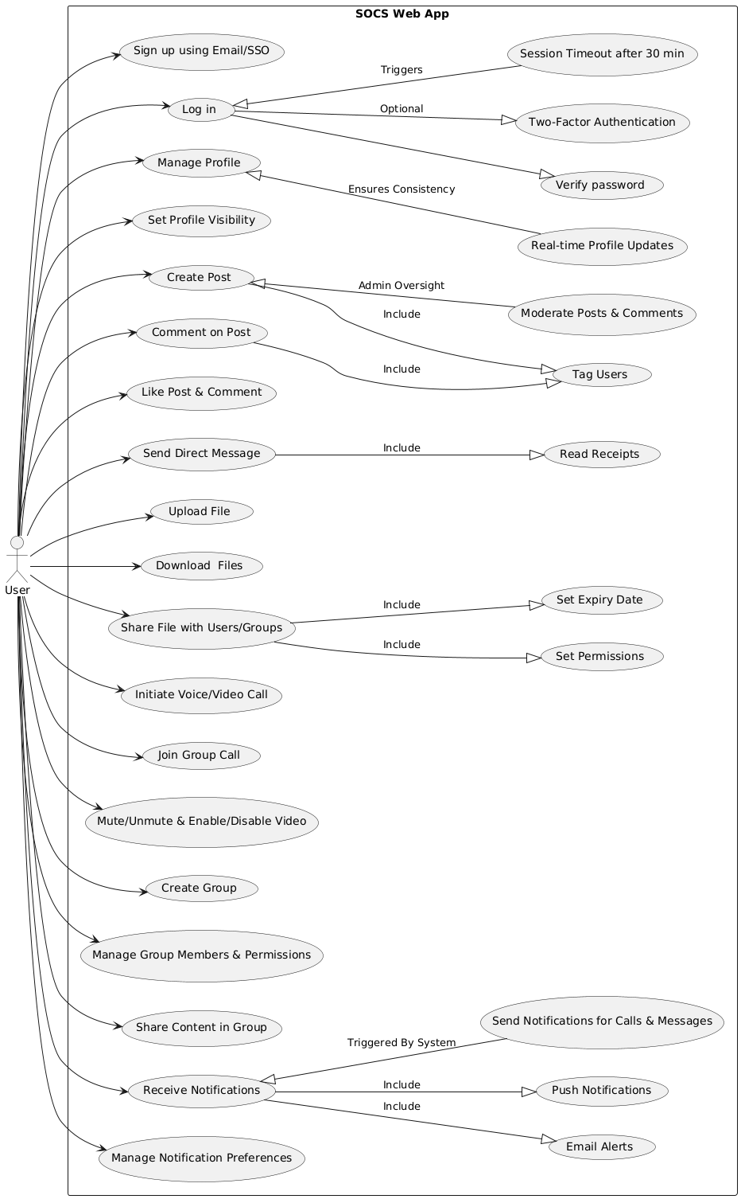

3.2.3. Use Case Description Tables

1. User Authentication and Authorization
Use Case | User Story | Associated Business Rules | Use Case Description
User Account Creation | As a user, I want to create an account using my email or SSO so that I can access the platform | BR-001, BR--004 | The system allows users to sign up using an email or third-party authentication and stores user passwords using industry-standard encryption algorithms to ensure security.
Authentication | As a user, I want to log in securely so that I can access my account. | BR-002 | The system verifies user credentials and grants access. After 30 minutes of inactivity, the session expires.
User Profile Management | As an admin, I want to create, modify, and delete user profiles, while regular users can only manage their own profiles | BR-003 | Admins have full control over user profiles, while regular users can edit only their own profile details.

2. Profile and Content Management
Use Case | User Story | Associated Business Rules | Use Case Description
Profile Creation & Editing | As a user, I want to have a personal profile where I can display and update my information. | BR-005, BR-006 | The system allows users to create personal profiles with a display name, bio, and profile picture, which they can modify later.
Profile Visibility & Real-Time Updates | As a user, I want control over who can see my profile and for my changes to update instantly. | BR-007, BR-008 | Profiles and content are public by default, but users can adjust visibility settings. Profile updates are reflected in real-time.

3. Content Creation and Interaction
Use Case | User Story | Associated Business Rules | Use Case Description
Post Creation & Sharing | As a user, I want to create and share posts with text, images, videos, or links. | BR-009, BR-010 | Users can create and share posts, ensuring each post is tied to the author who created it.
Commenting & Engagement | As a user, I want to comment on posts and engage with them through likes and votes. | BR-011, BR-013 | Users can comment on posts, upvote/downvote comments, and like posts or comments to show engagement.
Direct Messaging | As a user, I want to send private messages to people I am connected with. | BR-012 | Direct messages can only be sent between users who are connected (followers or group members).

4. File Sharing and Storage
Use Case | User Story | Associated Business Rules | Use Case Description
File Upload & Download | As a user, I want to upload and download files with size limitations. | BR-015 | Users can upload and download files, with a platform-defined size limit
File Sharing & Permissions | As a user, I want to share files with individuals or groups while controlling access. | BR-014, BR-016 | Users can share files with specific users or groups, and shared files are stored in a central repository with access permissions.

5. Voice and Video Calls
Use Case | User Story | Associated Business Rules | Use Case Description
Initiating Calls | As a user, I want to start a voice or video call only if I have the necessary permissions. | BR-017 | Users can start voice or video calls with individuals or groups if they have the necessary permissions.
Group Calls | As a user, I want to have group voice and video calls with multiple participants. | BR-018 | Group calls can have a maximum of 10 participants.
Call Controls | As a user, I want to mute/unmute my microphone and enable/disable my video during calls. | BR-019 | During a call, users can mute/unmute themselves and enable/disable video.
Call Duration Limit | As a user, I want my calls to automatically disconnect after a certain duration to manage system resources. | BR-020 | Calls will automatically disconnect after 2 hours of continuous usage to prevent system overload.

6. Groups and Collaborative Features
Use Case | User Story | Associated Business Rules | Use Case Description
Group Creation | As a user, I want to create groups that can be either private or public. | BR-021 | Users can create groups and set their visibility as either private (invite-only) or public (open for anyone to join).
Group Membership Management | As a user, I want to invite others to my group and manage their roles and permissions. | BR-022 | Group owners can send invitations to users and assign roles (e.g., admin, member) with different permissions.
Group Content Access | As a user, I want to ensure that content shared within my group is only accessible to group members. | BR-023 | Content shared in groups, such as files, posts, and messages, is restricted based on the group’s privacy settings and only accessible to its members.

7. Notifications
Use Case | User Story | Associated Business Rules | Use Case Description
Real-Time Notifications | As a user, I want to receive real-time notifications for important activities. | BR-024 | Users receive instant notifications when they receive a new message, comment, or mention in a post.
Notification Preferences | As a user, I want to customize my notification settings. | BR-025 | Users can enable or disable notifications for specific events and choose how they receive them (email, SMS, or in-app alerts).
Call Notifications | As a user, I want to be notified when I am invited to a call or miss a call. | BR-026 | Users receive notifications when someone invites them to a voice or video call. Missed call notifications are also sent to alert the user.

4 - Domain Class Diagram

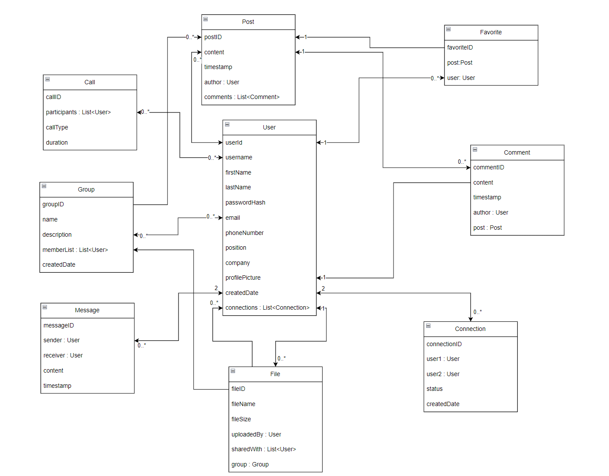

5 – Database Design

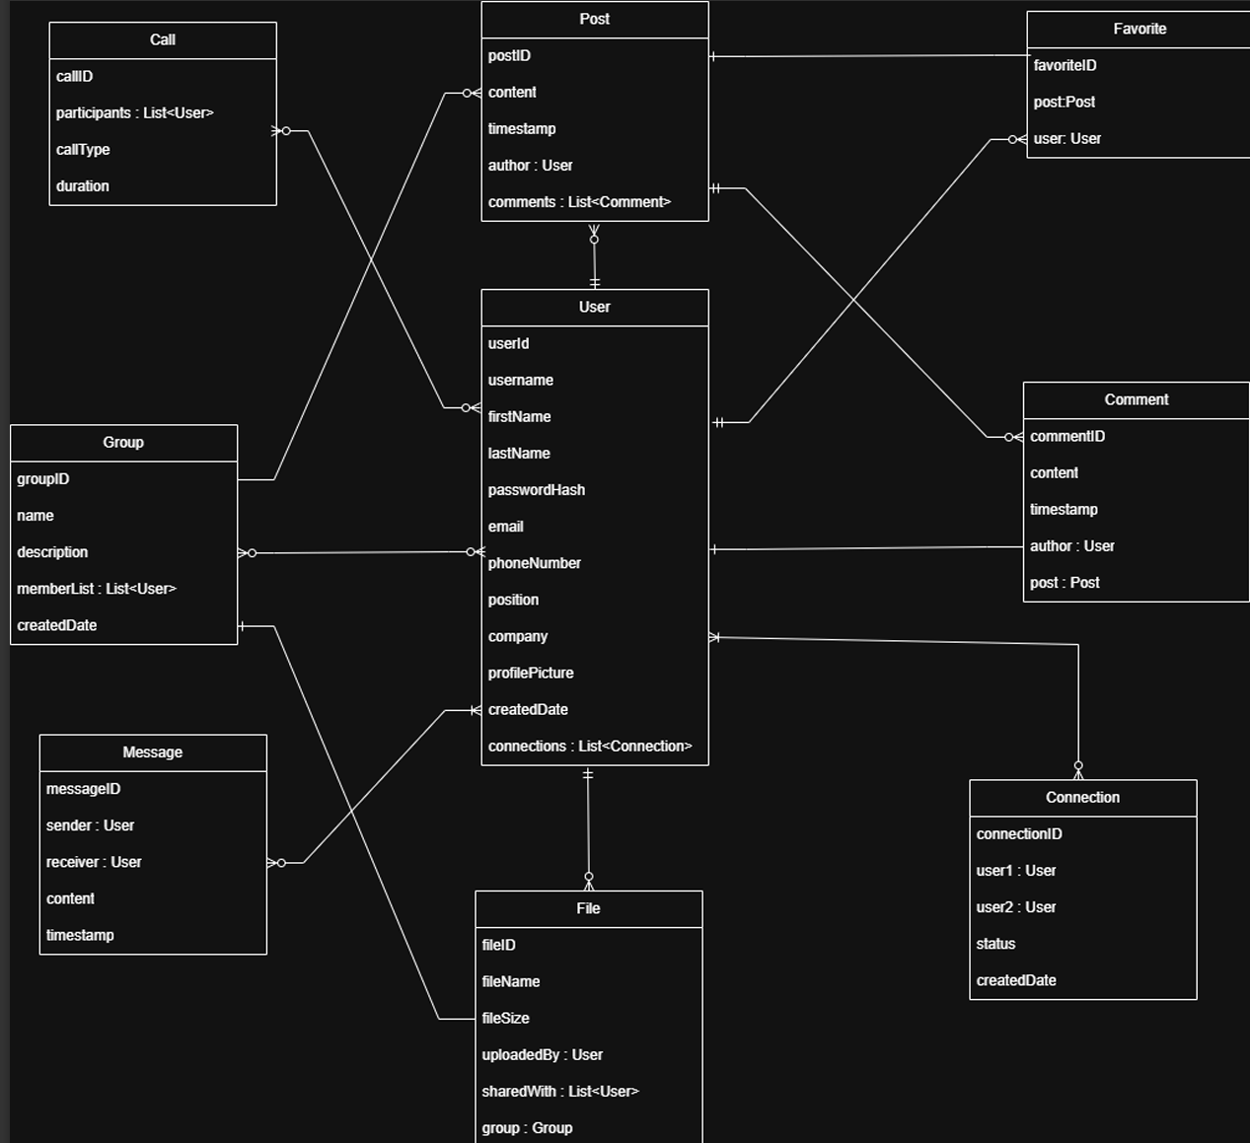

6 – Work breakdown Structure (WBS)

1.0 Project Planning & Infrastructure
- 1.1 Requirement Analysis & Backlog Setup
  - 1.1.1 User stories & use case definitions
  - 1.1.2 Business rule documentation
  - 1.1.3 Initial product backlog
- 1.2 Development Environment Setup
  - 1.2.1 Frontend (Next.js) setup
  - 1.2.2 Backend (Express.js) setup
  - 1.2.3 MongoDB schema design
  - 1.2.4 CI/CD pipeline via GitHub Actions
  - 1.2.5 Deployment environment on AWS EC2

2.0 Authentication System
- 2.1 Backend Authentication Implementation
  - 2.1.1 JWT/OAuth2 token logic
  - 2.1.2 Signup/Login API endpoints
- 2.2 Frontend Auth UI
  - 2.2.1 Login & Signup forms (Tailwind CSS)
  - 2.2.2 Error handling & validation
- 2.3 Security Middleware
  - 2.3.1 Route guards & session validation

3.0 User Profile & Connection Management
- 3.1 Profile Management
  - 3.1.1 Create/View/Update Profile API
  - 3.1.2 Avatar upload & bio editing
- 3.2 Connection System
  - 3.2.1 Follow/Unfollow API logic
  - 3.2.2 Profile Page UI Integration
- 3.3 Data & API Security Enhancements

4.0 SOCS Feed Module
- 4.1 Post System Backend
  - 4.1.1 Create/Update/Delete Post APIs
  - 4.1.2 Like & Comment APIs
- 4.2 Feed Frontend
  - 4.2.1 Dynamic feed UI
  - 4.2.2 Pagination & lazy loading
- 4.3 Performance Optimization
  - 4.3.1 Query optimization
  - 4.3.2 Rate limiting on actions

5.0 Messaging & Notifications
- 5.1 Real-Time Messaging
  - 5.1.1 Socket.io integration
  - 5.1.2 Message schema & storage
- 5.2 Chat UI
  - 5.2.1 Direct messaging interface
  - 5.2.2 Notification system (unread messages)

6.0 Deployment & DevOps
- 6.1 Frontend Deployment
  - 6.1.1 Deploy Next.js on Vercel
- 6.2 Backend Deployment
  - 6.2.1 EC2 configuration (PM2, Nginx)
  - 6.2.2 Reverse Proxy with SSL (Let's Encrypt)
- 6.3 Media Storage
  - 6.3.1 Configure AWS S3 for uploads
- 6.4 API Security
  - 6.4.1 Rate limiting
  - 6.4.2 Helmet & CORS policies

7.0 Search & UI Optimization
- 7.1 Search Functionality
  - 7.1.1 User/Post/Message search API
  - 7.1.2 Frontend search UI
- 7.2 API & UX Enhancements
  - 7.2.1 API caching
  - 7.2.2 Responsive & interactive UI tuning

8.0 Testing & Bug Fixes
- 8.1 Beta Testing
  - 8.1.1 User testing sessions
  - 8.1.2 Collect feedback
- 8.2 Bug Resolution
  - 8.2.1 Performance fixes
  - 8.2.2 UI corrections & cleanup
- 8.3 Database Query Optimization

9.0 Final Launch & Roadmap
- 9.1 Final Testing
  - 9.1.1 Regression & smoke testing
  - 9.1.2 Final QA approval
- 9.2 Public Launch
  - 9.2.1 Announce & deploy final version
- 9.3 Post-launch Roadmap
  - 9.3.1 Document future features (Groups, Video Calls, AI recommendations)

7 – Milestones & Acceptance Criteria
Milestone ID | Milestone Name | Sprint | Milestone Description | Acceptance Criteria
M1 | Authentication System Ready | 1 | Setup of the SOCS development stack, user authentication, and initial deployment completed | - Users can sign up/login via OAuth and JWT  - Backend deployed to AWS EC2  - GitHub Actions CI/CD configured
M2 | Profile & Connections Functional | 2 | User profile management and social connection (follow/unfollow) features implemented | - Users can update/view profiles  - Follow/unfollow APIs work with secure access  - Profile UI integrated
M3 |  | 3 | Core SOCS feed with posts, likes, and comments is functional and accessible | - Users can create/update/delete posts  - Can like and comment on posts  - Feed supports pagination
  SOCS Feed Operational
M4 |  | 4 | Real-time messaging system using WebSocket’s is fully integrated | - Users can send/receive real-time messages  - Message history stored  - Notifications trigger on new messages
  Real-time Messaging Live
M5 | MVP Fully Deployed Securely | 5 | Platform is deployed publicly with front/backend separation, media storage, and baseline security | - Frontend live on Vercel  - Backend secured behind Nginx reverse proxy  - AWS S3 integration completed
M6 |  | 6 | Search functionality and performance enhancements introduced | - Users can search for posts/users  - API caching implemented  - UI/UX enhancements based on user flow
  Search & Discovery Features Enabled
M7 | Stable Beta Release | 7 | Beta version tested with real users, optimized for performance and bug fixes applied | - Feedback gathered from users  - All critical bugs fixed  - Database and APIs optimized for speed
M8 | Official MVP Launch & Roadmap Delivered | 8 | Final version ready for launch with future development roadmap presented | - Last-minute fixes applied  - Launch announcement materials prepared  - Roadmap includes Groups, AI Feed, Video Call

7.1 – Product Backlogs
ID | Use Case | User Story | Associated Business Rules | Use Case Description | Priority | Notes
1 | User Account Creation | As a user, I want to create an account using my email or SSO so that I can access the platform. | BR-001, BR-004 | The system allows users to sign up using email or third-party authentication and stores passwords securely. | High | Core feature for user onboarding
2 | Authentication | As a user, I want to log in securely so that I can access my account. | BR-002 | The system verifies credentials and grants access. Session expires after 30 minutes of inactivity. | High | Critical security functionality
3 | User Profile Management | As an admin, I want to create, modify, and delete user profiles, while regular users can only manage their own profiles. | BR-003 | Admins have full control, while regular users can edit only their own profile details. | Medium | Necessary for user management
4 | Profile Creation & Editing | As a user, I want to have a personal profile where I can display and update my information. | BR-005, BR-006 | The system allows users to create and edit their profiles. | High | Essential user experience
5 | Profile Visibility & Real-Time Updates | As a user, I want control over who can see my profile and for my changes to update instantly. | BR-007, BR-008 | Profiles are public by default, but users can adjust visibility and real-time updates occur. | Medium | Enhances privacy and UX
6 | Post Creation & Sharing | As a user, I want to create and share posts  with text, images, videos, or links. | BR-009, BR-010 | Users can create and share posts, and each post is tied to the author. | High | Core content creation feature
7 | Commenting & Engagement | As a user, I want to comment on posts and engage with them through likes and votes. | BR-011, BR-013 | Users can comment, like, and vote on posts/comments to engage. | Medium | Enhances social interaction
8 | Direct Messaging | As a user, I want to send private messages to people I relate to. | BR-012 | Messaging is only available between connected users (followers/group members). | Medium | Adds social functionality
9 | File Upload & Download | As a user, I want to upload and download files with size limitations. | BR-015 | Users can upload/download files within a platform-defined size limit. | Medium | Enhances content sharing
10 | File Sharing & Permissions | As a user, I want to share files with individuals or groups while controlling access. | BR-014, BR-016 | Files can be shared with specific users/groups with permissions managed centrally. | Medium | Improves file management
11 | Initiating Calls | As a user, I want to start a voice or video call only if I have the necessary permissions. | BR-017 | Calls can be initiated if users have the necessary permissions (e.g., group admin, mutual followers). | Low | Optional feature for early stages
12 | Group Calls | As a user, I want to have group voice and video calls with multiple participants. | BR-018 | The group calls support up to 10 participants. | Low | Future enhancement for group communication
13 | Call Controls | As a user, I want to mute/unmute my microphone and enable/disable my video during calls. | BR-019 | Call participants can control their microphone and video settings during calls. | Low | Enhances call functionality
14 | Call Duration Limit | As a user, I want my calls to automatically disconnect | BR-020 | Calls are disconnected after 2 hours to prevent system overload. | Low | System optimization
15 | Group Creation | As a user, I want to create groups that can be either private or public. | BR-021 | Users can create groups with private or public visibility. | Medium | Encourages collaboration
16 | Group Membership Management | As a user, I want to invite others to my group and manage their roles and permissions. | BR-022 | Group owners can invite users and assign roles with varying permissions. | Medium | Supports group management
17 | Group Content Access | As a user, I want to ensure that content shared within my group is only accessible to group members. | BR-023 | Content within groups is accessible only to members based on group privacy settings. | Medium | Enhances group privacy
18 | Real-Time Notifications | As a user, I want to receive real-time notifications for important activities. | BR-024 | Instant notifications are sent when users receive new messages, comments, or mentions. | High | Core feature for user engagement
19 | Notification Preferences | As a user, I want to customize my notification settings. | BR-025 | Users can enable/disable notifications for specific events (email, SMS, or in-app). | Medium | Customizes user experience
20 | Call Notifications | As a user, I want to be notified when I am invited to a call or miss a call. | BR-026 | Users are notified when invited to a call and for missed calls. | Low | Enhances call exp

8 – Implementation Schedule (Agile)
Sprint | Timeline | Sprint Objective | Major Activities | Key Deliverables (Milestone)
1 | Week 1-2 | Project Setup & Authentication | - Initialize project: Next.js (Frontend), Express.js (Backend)  - Design MongoDB schema & ORM  - Implement OAuth/JWT Authentication  - Build Signup/Login API & UI  - Set up CI/CD via GitHub Actions  - Deploy backend to AWS EC2 | Functional Signup/Login System with Authentication
2 | Week 3–4 | User Profiles & Social Graph | - Build profile management: View/Update  - Develop Follow/Unfollow feature  - Integrate Profile UI (Next.js + Tailwind)  - Enhance DB schema & apply API security improvements | Users can manage profiles and connect with others (follow/unfollow)
3 | Week 5–6 | SOCS Feed (Posts, Likes, Comments) | - Develop post CRUD APIs  - Implement like and comment functionality  - Design SOCS Feed UI  - Optimize API with pagination for scalability | Dynamic, interactive feed with user-generated content
4 | Week 7–8 | Real-Time Messaging System | - Integrate Socket.io for live chat  - Develop message schema & storage  - Build chat UI & basic notifications | Real-time messaging with persistent chat data
5 | Week 9-10 | Deployment & API Security | - Frontend deployment on Vercel  - Backend hosting via AWS EC2 with Nginx  - Media storage integration via AWS S3  - Enable SSL, reverse proxy, rate limiting, and security headers | Live production deployment with essential security controls
6 | Week 11–12 | Search & System Optimization | - Implement User & Post Search APIs  - Enhance caching and query performance  - UI improvements for enhanced UX | Users can search and explore the platform efficiently
7 | Week 13–14 | Beta Testing & Refinement | - Conduct structured beta testing  - Collect and analyze feedback  - Fix bugs and performance | SOCS MVP stabilized and optimized
8 | Week 15–16 | Final Testing & Launch | - Execute final testing & QA  - Final feature tuning and bug fixes  - Prepare for launch (docs, release notes)  - Define roadmap for post-launch features (e.g., Groups, AI, Video Calls) | SOCS officially launched with roadmap for future enhancements

9- Client / Faculty Sign-off

Date: ______________________

X .
Name of Client/Rep/Professor

